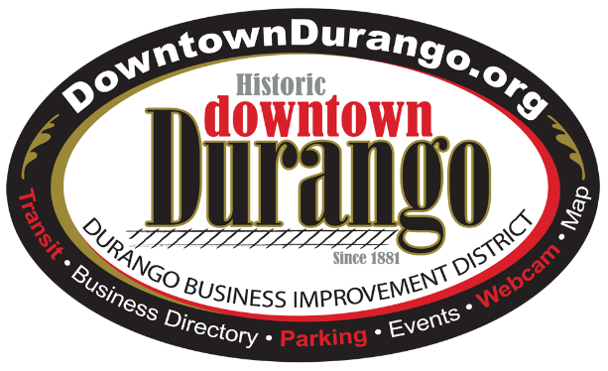

**April 14, 2017**

**NEWS**

For further information please contact:

Tim Walsworth, Executive Director, 970.375.5068

**Business Improvement District Town Hall Apr. 25 to discuss panhandling**

***BID teams up with Chamber of Commerce, Local First to address pressing issue***

DURANGO, Colo. – The Durango Business Improvement District (BID), with support of the Durango Chamber of Commerce and Local First, will host a Town Hall, Tuesday, Apr. 25, 2017, 8:30-10 a.m. at the Durango Public Library to discuss possible solutions for the growing issue of panhandling in the City. Business owners and store managers are specifically invited to attend to provide input.

“As the weather warms up, we’re seeing the panhandlers return,” said Tim Walsworth, BID executive director. “What we hope to accomplish with the Town Hall is to gather ideas for what to do about those people who have chosen panhandling as a lifestyle, the transient panhandlers who are impacting the safety, charm and allure of our community.”

In 2016 the BID launched the “Make it Count” program to encourage community members and visitors to give to non-profit organizations that assist those truly in need rather than giving money to transient panhandlers. Nearly $1,000 was raised and donated to the Volunteers of America Community Shelter, an organization that strictly prohibits its clients from panhandling.

“That was $1,000 that was not collected by transient panhandlers,” said Walsworth, who noted the Make it Count program will be enhanced this season. “The idea is that if we eliminate their income stream they will either find real employment or move on. We hope to have 100 businesses participating in Make it Count this season, and we’ll have the donation boxes and posters available at the Town Hall.”

The BID has engaged in on-going research about managing the panhandling issue and will discuss possibilities such as increased downtown lighting, increased walking police patrols, addition of more window flower boxes or bistro tables to limit sidewalk panhandling space and more. Ideas generated at the Town Hall will be evaluated by the BID, Chamber of Commerce and Local First, then taken to the appropriate group or organization best suited to implement each proposed project.

“It will take multiple ideas and efforts all working toward the goal to reduce the transient panhandling issue,” said Walsworth. “We must work together.”

For additional information about all BID programs*,* visit [www.DowntownDurango.org](http://www.DowntownDurango.org) or call 970.375.5067.

*The Durango Business Improvement District was formed in 1997 with a goal and mission to support businesses within the District by assisting with special event marketing, providing research on topics of concern to the District (facilities, special events, best practices), planning and development of new facilities, and providing capital budget for equipment that enhances business in the District. Funding is generated by a 2 mill levy on property owners within the district, with additional marketing dollars contributed by the City of Durango.*

# # #